LEAVING CERTIFICATE COMPUTER SCIENCE

APPLIED LEARNING TASK 2: ANALYTICS

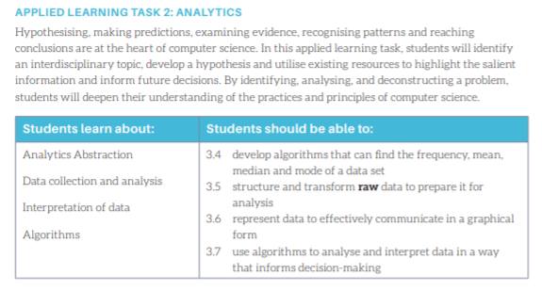

Dates:

Project Assigned: 23rd October
Project Due: 20th November

Theme:

You are required to perform a data analysis project. The project should put forward a hypothesis that should be then tested using data analysis tools and a conclusion reached.
The topic of your analysis can be anything of your choosing. Your project should follow the Data Science Arc process and check off each of the learning outcomes listed above.

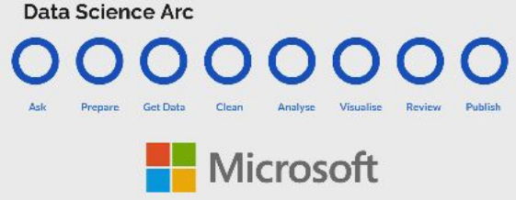
The Project:

- Getting Started
First identify a topic where data analytics would be useful. This might mean looking at population statistics, historical data, vocabulary use in English, surveying students, analysing social media posts, movies, music, art, Sport…..there are lots of options. Remember you are looking for datasets that you can find the mean, median, mode and frequency of. Brainstorm ideas and research further before deciding what your hypothesis might be.

Examples of a hypothesis:
There are more people unemployed during an economic downturn
More crimes are committed in cities
A team is more likely to score in home games
Coronavirus cases are higher in urban cities than rural areas

- Source, Collect, Clean and Transform Data

Source/Collect:
Once you have decided on your topic, you need to gather/collect data. Make sure to save it somewhere that you have access to it. The data can be obtained from a third party source or collected directly through observation, monitoring or sensing (including use of a Microbit).

Clean/Transform:
- Check what format it is currently stored in (.xlsx, .csv, .txt) and does it need to be converted?
- Are there any symbols, characters etc that you need to remove?

- Algorithms for Processing Data
When your data is ready, use algorithms to find the mean, median and mode (if possible). You can use the statistics module in Python but it is better if you try to code them yourself.

- Data Visualisation
Once your data is processed, it must be visualised to make it easier to interpret. This is done by creating one of more graphs.

- Data Interpretation
Interpret your findings. How does it compare with your hypothesis and what future predictions or decisions will it affect?

Final Report:

The final report should be presented as a web page and be structured according to the headings below.

- Research
Brainstorm any ideas that you think you might consider doing - create a mind map, poster or just list them

Choose three of your ideas and research them further.
- Where did you read about or find out about this topic?
- What websites/videos did you view?
- Is there data available on this topic and is it from a trusted source?
- Is the data suitable for this assignment? Why or why not?

Decide on a topic, hypothesis and dataset.

- Response to the brief
Why are you choosing this topic?
Who do you think will benefit from this information?

- Design and Development
The iterative design process
You should show evidence of an iterative design approach, in line with this process. There should be a description of how the project evolved through the iterations.
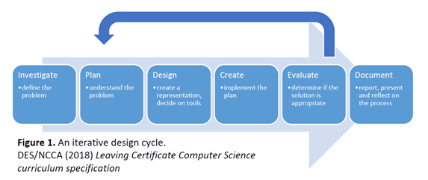
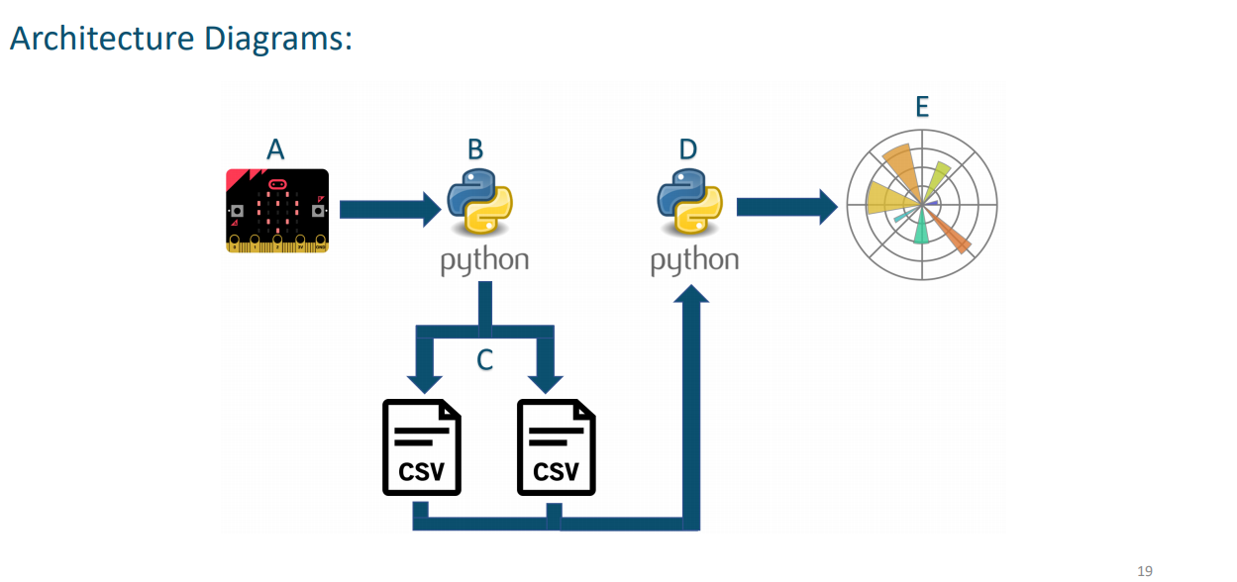
Plan - The project should be broken into definite tasks along with a timeline. An architecture diagram should be drawn (Example shown for our Microbit Reading assignment)

Detail what you plan on doing BEFORE CODING including the following:

Include the following:
- Overall plan (like architecture diagram above)
  - Example: I will store my data in a csv file. I will read it into Python. I will use algorithms to process it. I will use Matplotlib to create a graph. I will output the results to the user.

Now break down that plan into separate parts

Data
- Where you got your data
- What format was it in?
- What did you have to do in order to get it into a csv file that you can use?
- Are there any symbols or characters that need to be removed from your data before you use it? If so, how are you planning on doing that
- Where have you stored the file?

Python
- Explain in detail what you will do.
  - I will import the csv and matplotlib libraries to use
  - Example: I will set up 2 empty lists called …. that I will use to store my data that I will read from the csv file.
  - I will use the csv reader to open and read my csv file.
  - I will loop though each row in the csv file and store the data in the 2nd column in my list etc
- Do any of your lists need to be converted to int or float - why?
- How are you going to find the mean, median or mode.

Graph
- Graphical output - describe the graphical output you chose and why.
  - Example: I am choosing a line graph because I want to graph two sets of data and it will be easier to show the difference between them etc

Flowcharts and Pseudocode can be included.

Development
Implement your plan.
Take note of any issues you have and how you went about solving them - include code snippets or pictures

- Evaluation
Reflection on meeting the brief
What have you learned from the data?
How does it compare to your hypothesis?
Did you manage to do all you set out to?
Do you think you met the requirements and if so how or why not?

Future development
How might you grow/add to/improve the project and why?
If you had more time, what would be the next thing to work on?

Submission:

All of the following must be submitted

- Report as detailed above
- Full code (Thonny file(s))
- Dataset

Creating a Website

You can create a website using one of the following:

- Create a weblab project on www.code.org
- Create a new project on www.glitch.com
- Create a google Site (from your drive)

Some templates to help:
https://lccs-cwa-template-carousel.glitch.me/
https://glitch.com/~blush-learning

HTML/CSS Help:

If you can’t remember how to create a webpage or add content to a webpage, these might help.

Code.org Web Development Course
W3 Schools HTML Tutorial
W3 Schools CSS Tutorial

DataSets

You can source data from lots of places. Here are some websites to try - bear in mind that just because there is a dataset, it doesn’t mean that it will be nice and easy to use so look at it first.
If you are using Google to search make sure you put the word “dataset” in your search.

https://datasetsearch.research.google.com/

https://data.gov.ie/dataset

https://docs.google.com/spreadsheets/d/1vg6eg17yNNs70PSy3Ehd3MIqYL5UNhe2aR4OwxQGQtQ/edit#gid=0

https://www.cso.ie/en/index.html

https://corgis-edu.github.io/corgis/python/
https://corgis-edu.github.io/corgis/python/
https://www.met.ie/climate/available-data
https://knoema.com/WBCC2019/world-bank-climate-change
https://data.world/datasets/global-warming
https://developers.google.com/earth-engine/datasets/catalog/

